RESOLUTION NO.__________

RE: CERTIFICATE OF APPROPRIATENESS UNDER THE
PROVISIONS OF THE ACT OF THE PENNSYLVANIA
LEGISLATURE 1961, JUNE 13, P.L. 282 (53
SECTION 8004) AND BETHLEHEM ORDINANCE NO.
3952 AS AMENDED.

WHEREAS, it is proposed to replace the windows at 7 E 4th St.

NOW, THEREFORE, BE IT RESOLVED by the Council of the City of Bethlehem that a Certificate of Appropriateness is hereby granted for the work.

Sponsored by: (s)

(s)

ADOPTED BY COUNCIL THIS DAY OF

(s)
President of Council

ATTEST:

(s)
City Clerk

HISTORIC CONSERVATION COMMISSION

CASE # 442 – It is proposed to replace the windows at 7 E 4th St.
OWNER/APPLICANT: Dave Fry & Cindy Dinsmore

The Commission upon motion by Mr. Roeder seconded by Mr. Lader adopted the proposal that City Council issue a Certificate of Appropriateness for the proposed work described herein:

- The proposal to replace the windows at 7 E 4th St. was presented by Bruce Wilson.

- The new windows will be Trim Line brand wood windows clad with white aluminum.

- The new windows will have the same configuration as the existing and will be custom made to fit the existing openings.

- The casings may be covered with a factory supplied aluminum extrusions or break metal.

- The proposed motion was unanimously approved.

CU: cu

By: 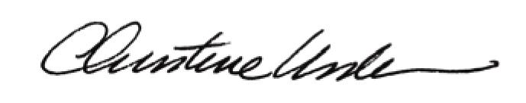

Date of Meeting: January 28, 2013 Title: Historic Officer

